**Practical no. 01**

**FS19CO042**

**Aim:** Identify components of Network and study Local Area Network in your Lab.

**Required Components:** PCs, Switch, Routers, Cable, Repeater, etc.

**Steps:**

Create a Network

You can easily create a network /topology using Cisco Packet Tracer. In the following sections, we are going to explain how to create a network topology that will contain four PCs, two switches, and two routers.

Adding PCs in Cisco Packet Tracer.  
To add PCs in Cisco Packet Tracer, you need to perform the following steps:

1. In the Cisco Packet Tracer console, click on the PC icon, click Generic, and then click in the logical view area to add a Generic PC.

2. Repeat the same step to add three more Generic PCs in the logical view area, as shown in the following figure.

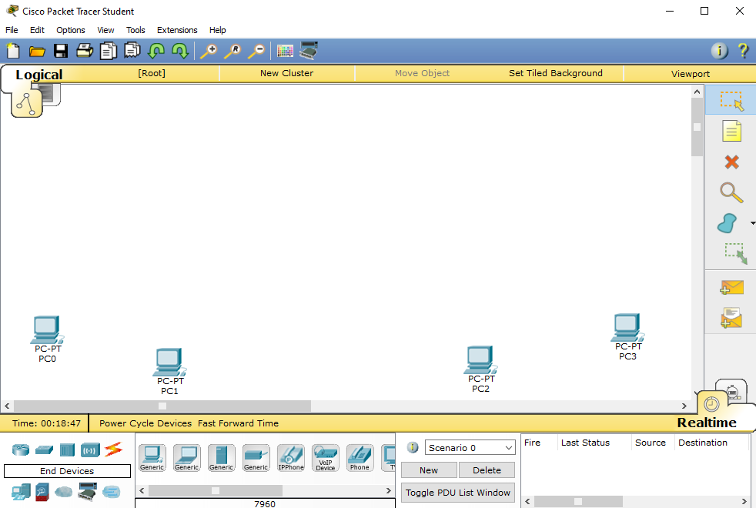

Adding Switches in Cisco Packet Tracer

1. To add a switch in Cisco Packet Tracer, click the Switch icon, select a switch type, such as 2960, and then add the selected switch in the logical view area.

2. Repeat the same step to add one more switch.

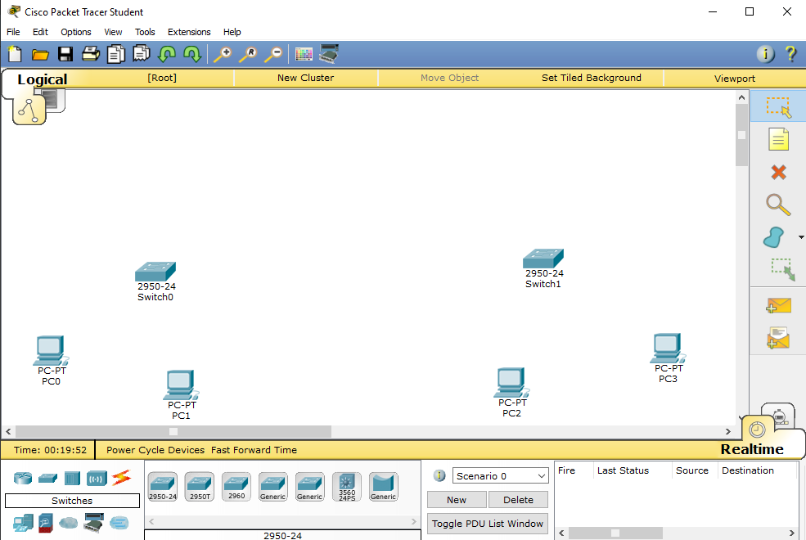

Adding Routers in Cisco Packet Tracer

1. To add a router in Cisco Packet Tracer, click the Router icon, select a router type, such as 2811, and then add the selected router in the logical view area.

2. Repeat the same step to add one more router. Note: Different types of router series provide different types of features and limitations.

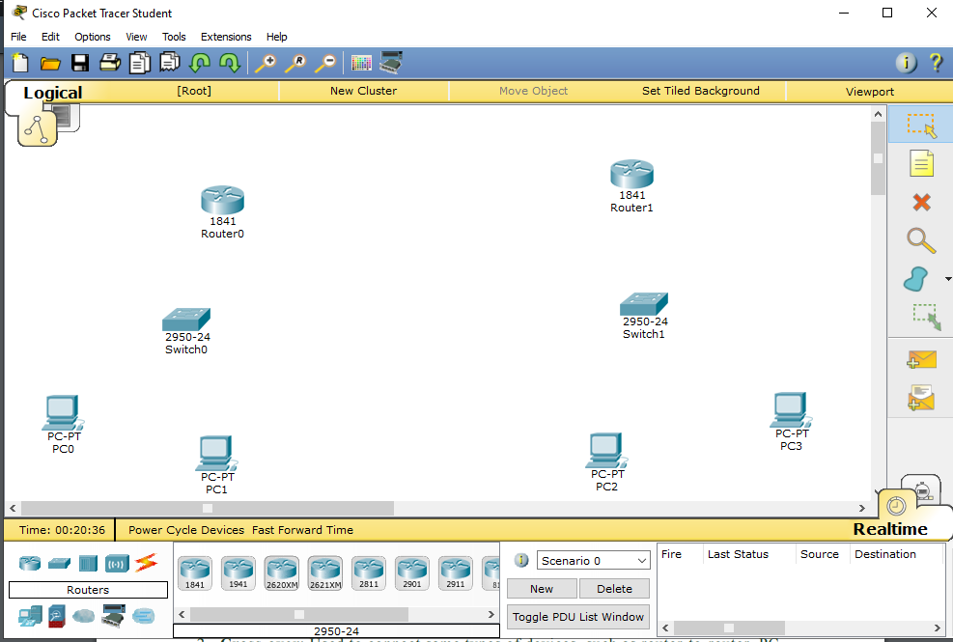

Understanding Connection Types in Cisco Packet Tracer

To connect devices in Cisco Packet Tracer, first, you need to understand the various types of cables (connections) used to connect network devices. Some of the common types of cables are:

1. Straight-through: Used to connect different types of devices (devices that use different wiring standards), such as Router-to-Switch and Switch-to-PC.   
2. Cross-over: Used to connect same types of devices, such as router-to-router, PCto-PC, and switch-to-switch.   
3. Serial DCE: Used to connect router-to-router in a WAN network.

4. Console: Used to take console (using hyper terminal) of a router on a PC.

To see the various types of connections, click the Connection icon. Spend some time to understand the connections. Once you are familiar with the types of connections, connect the devices to create the network topology.

The following figure displays the various types of connections used to connect devices

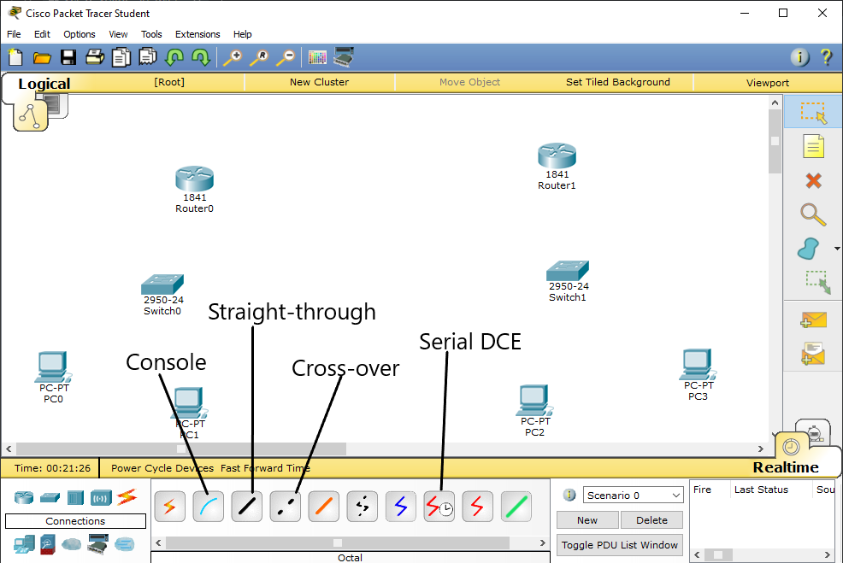

Following figure displays how to add module in router in Cisco packet tracer.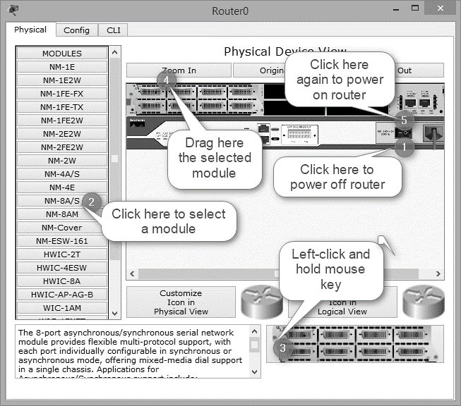

Now, open the Router1 properties dialog box, add the same module to Router1 also, and then close the Router1 properties dialog box.

Connecting Devices in Cisco Packet Tracer

1. To connect devices in Cisco Packet Tracer, click the connection type icon, and select an appropriate cable. For example, to connect PC0 to Switch0, select the straight-through cable, click on PC0, select the FastEthernet0 interface.
2. Next, click on Switch0, and then select the FastEthernet0/1 interface. The following figure displays how to connect a PC to a switch in Cisco Packet Tracer.

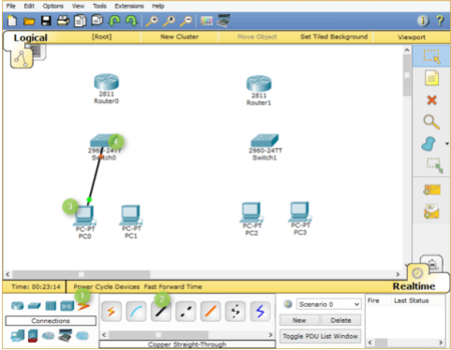

1. Now, add PC1 to Switch0 using the FastEthernet0/2 interface. Also, add PC2 and PC3 to the FastEthernet0/1 and FastEthernet0/2 interfaces of Switch1, respectively.
2. . If you have connected a wrong device to a wrong interface, you can use the Delete option to delete a connection or device. The following figure displays how to use the Delete option to delete a device or connection in Cisco Packet

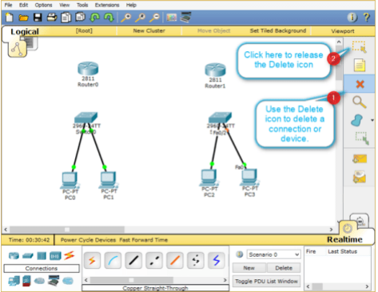

1. Once, you have connected all the PCs to switches, now, connect Switch0 to Router0, and Switch1 to Router1 using the straight-through cables.
2. Select the straight-through cable, click on Switch0, and then select FastEthernet0/3 interface.
3. Click Router0 and select the FastEthernet0/0 interface.
4. Select again the straight-through cable, click on Switch1, and select FastEthernet0/3 interface.
5. Next, click Router1 and then select the FastEthernet0/0 interface.

The following figure displays how to connect routers to switches to create a network topology

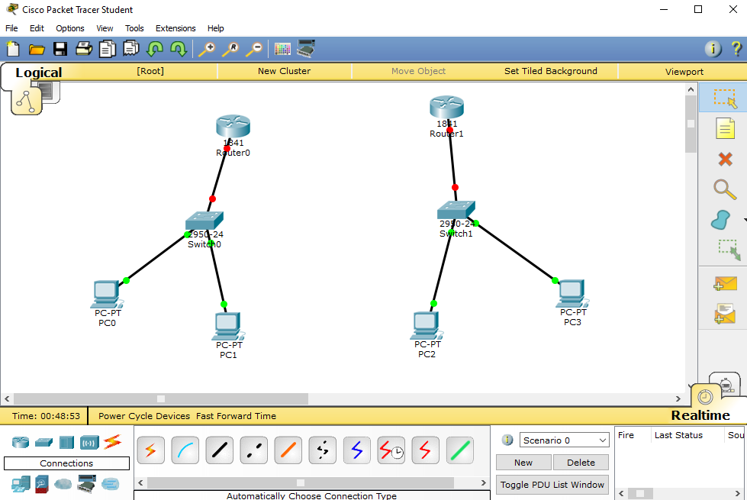

Interconnecting Routers in Cisco Packet Tracer

Now, connect Router0 to Router1 using the serial connection. To do this, you need to perform the following steps:

1. Select the Serial DCE cable, click on Router0, and select the Serial1/0 interface.

2. Click on Router1 and select the Serial1/0 interface, as shown in the following figure.

Bus Topology In local area network, it is a single network cable runs in the building or campus and all nodes are connected along with this communication line with two endpoints called the bus or backbone. In other words, it is a multipoint data communication circuit that is easily control data flow between the computers because this configuration allows all stations to receive every transmission over the network. For bus topology we build network using three generic pc which are serially connected with three switches using copper straight through cable and switches are interconnected using copper cross over cable.

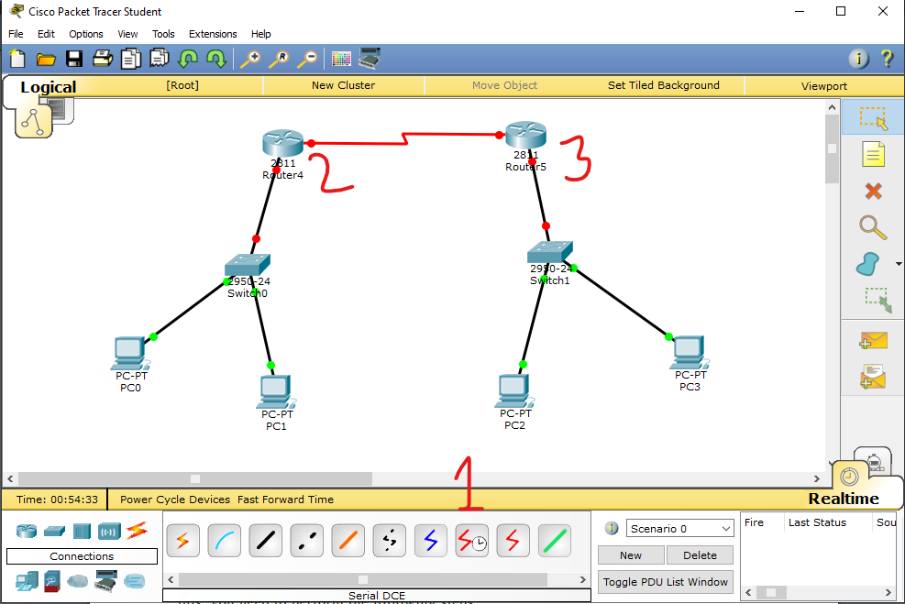

**Conclusion:** Thus, we created small network using various network components and understood their uses.